**Use image from SE78 in adobeforms**

1. Upload any image from local system through tcodeSE78.
2. Go to Tcode SFP .Create an interface and then create a form(For details ,please refer the previous demo)

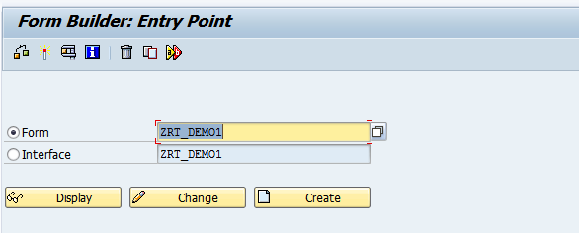

1. Open the interface. In the global data add the 2 variables

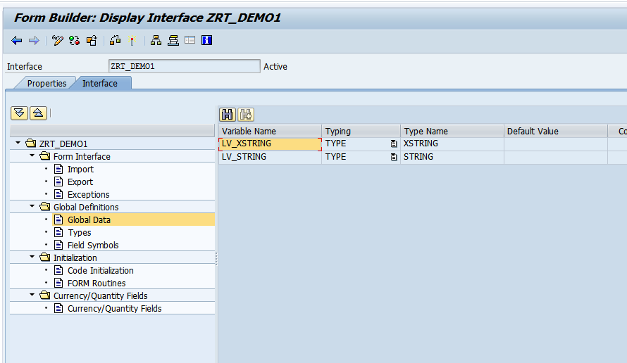

1. In the intialisation section, add the below code.

Note:'SAP_RT' is the name of the image uploaded in SE78

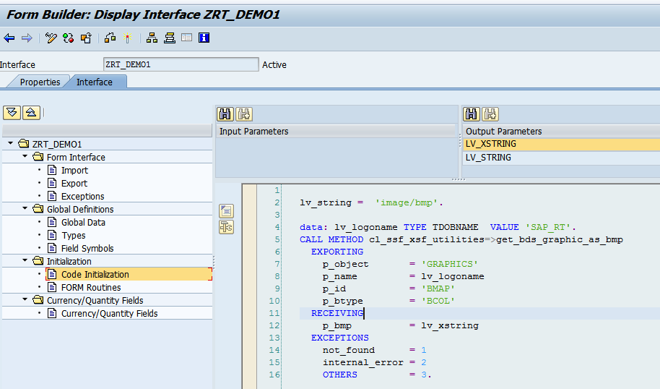

1. Open the Adobe form. In the context tab, right click on the folder ZRT_DEM01-Create-Graphic

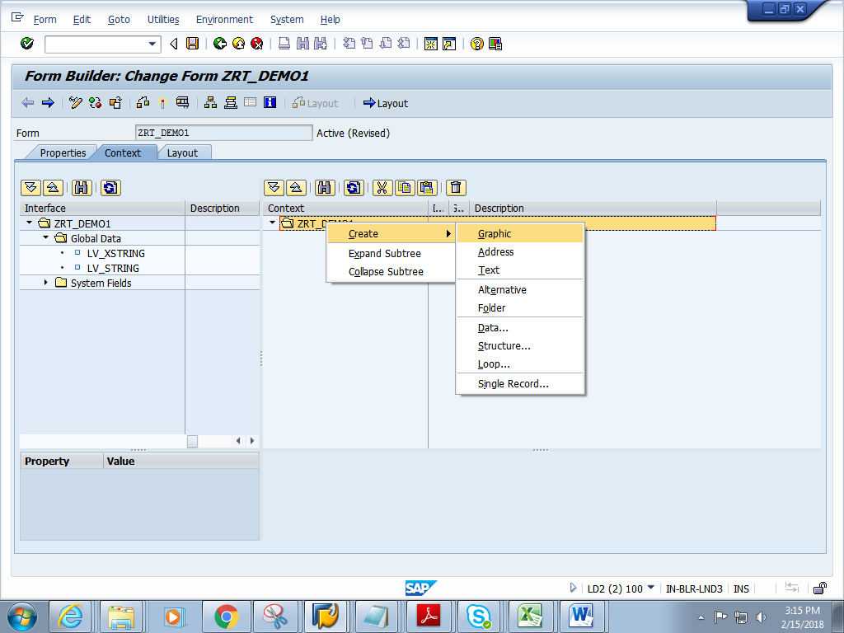

5) Double click the GRAPHIC. In the properties window, **change the Graphic type to GRAPHIC CONTENT**

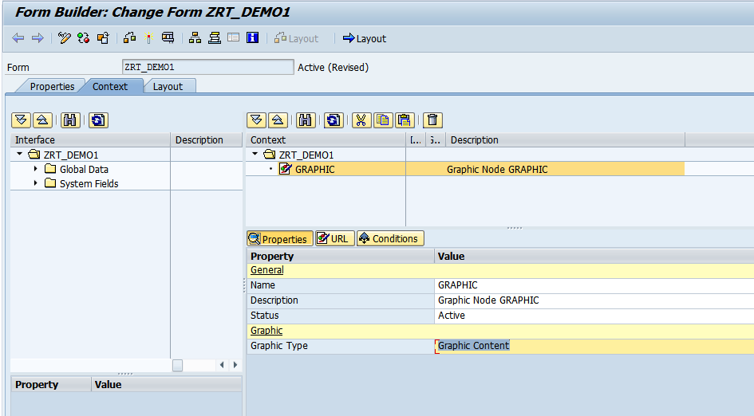

6)Give the Field and MIME type as shown below.Click on Layout

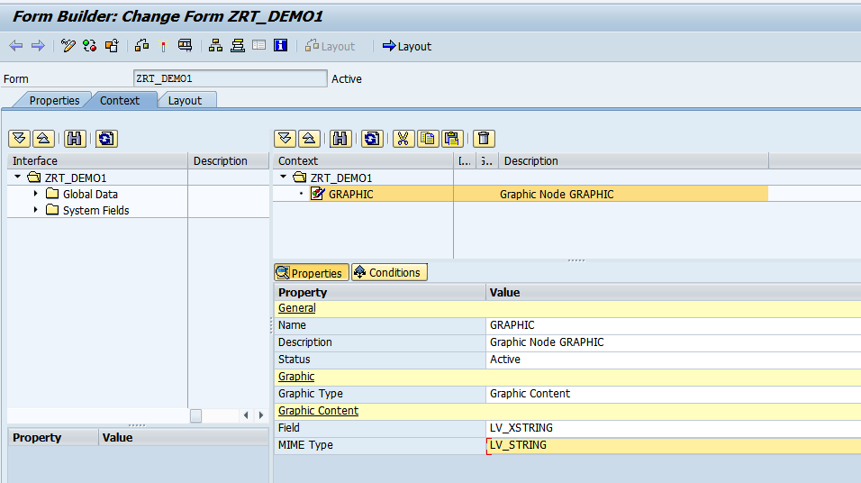

7) Drag and drop the Image Field to the Design View.

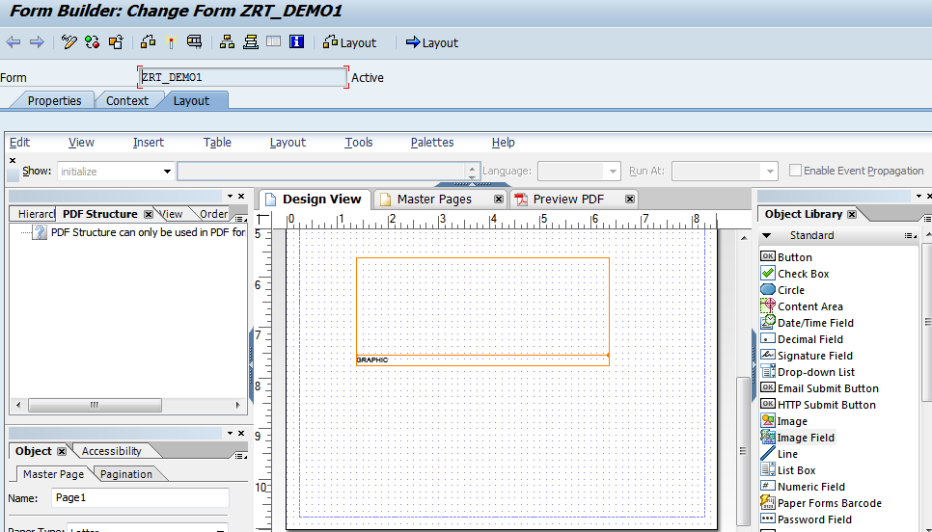

8) In the object window ,**Check the embed image data** check box.

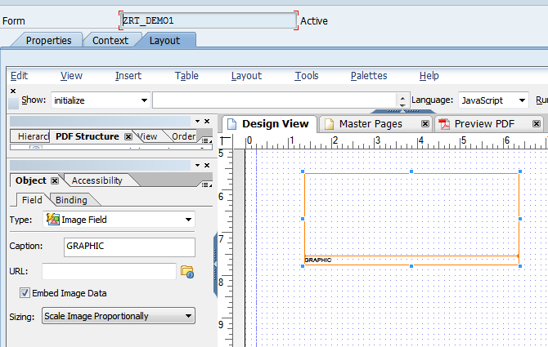

9) In the binding window, bind the GRAPHIC as shown below

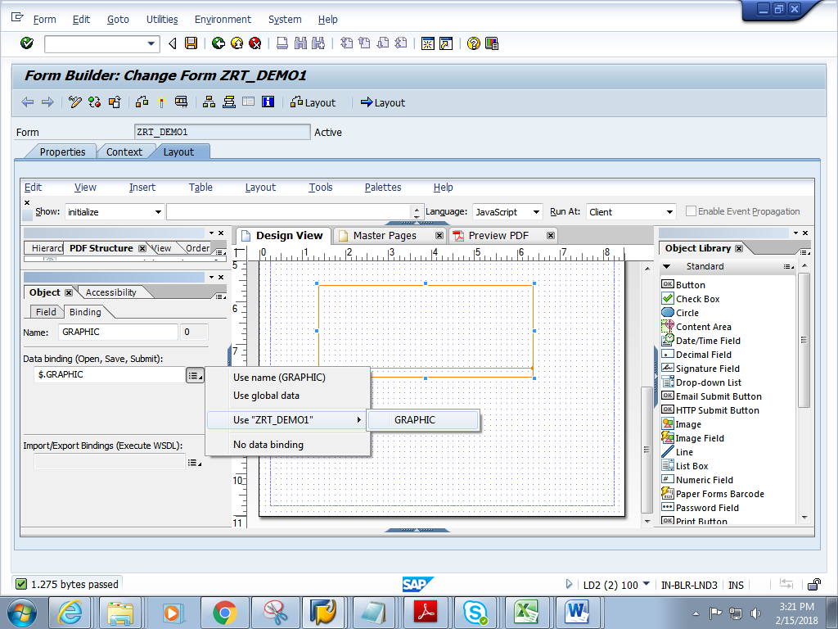

9) Click on context. Save and activate the form.

10) Execute the form .Execute the function module

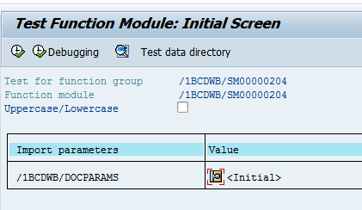

11) Click on Print preview

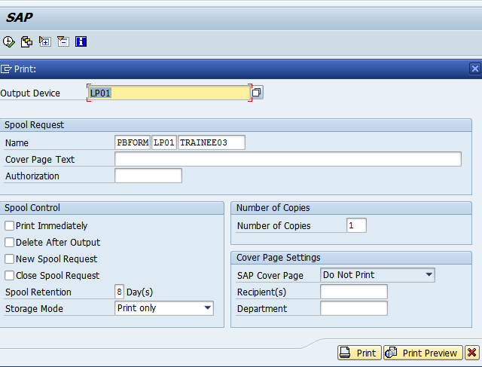

12) Expected output is as follows.

